Land Surface Temperature 2024

This was derived from Remote Sensed Data Landsat images band 5,6,7&8 from climate earth engine open source. The image was processed and clipped to contain the area of interest as Nairobi County.

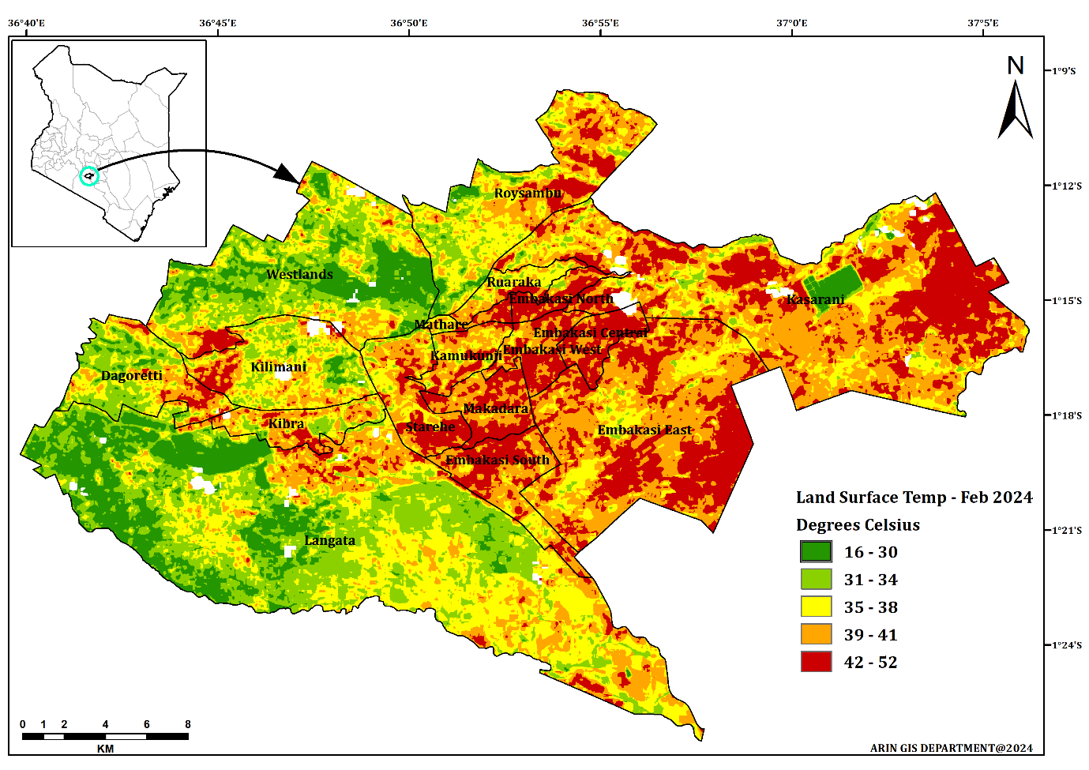

Land use land cover (LULC) are terms that describe the physical and human-related aspects of the Earth's surface:

* **Land cover**

The physical material that covers the Earth, including water, soil, rock, vegetation, roads, and buildings

* **Land use**

The activities that people perform on the land, such as agriculture, recreation, or wildlife habitat

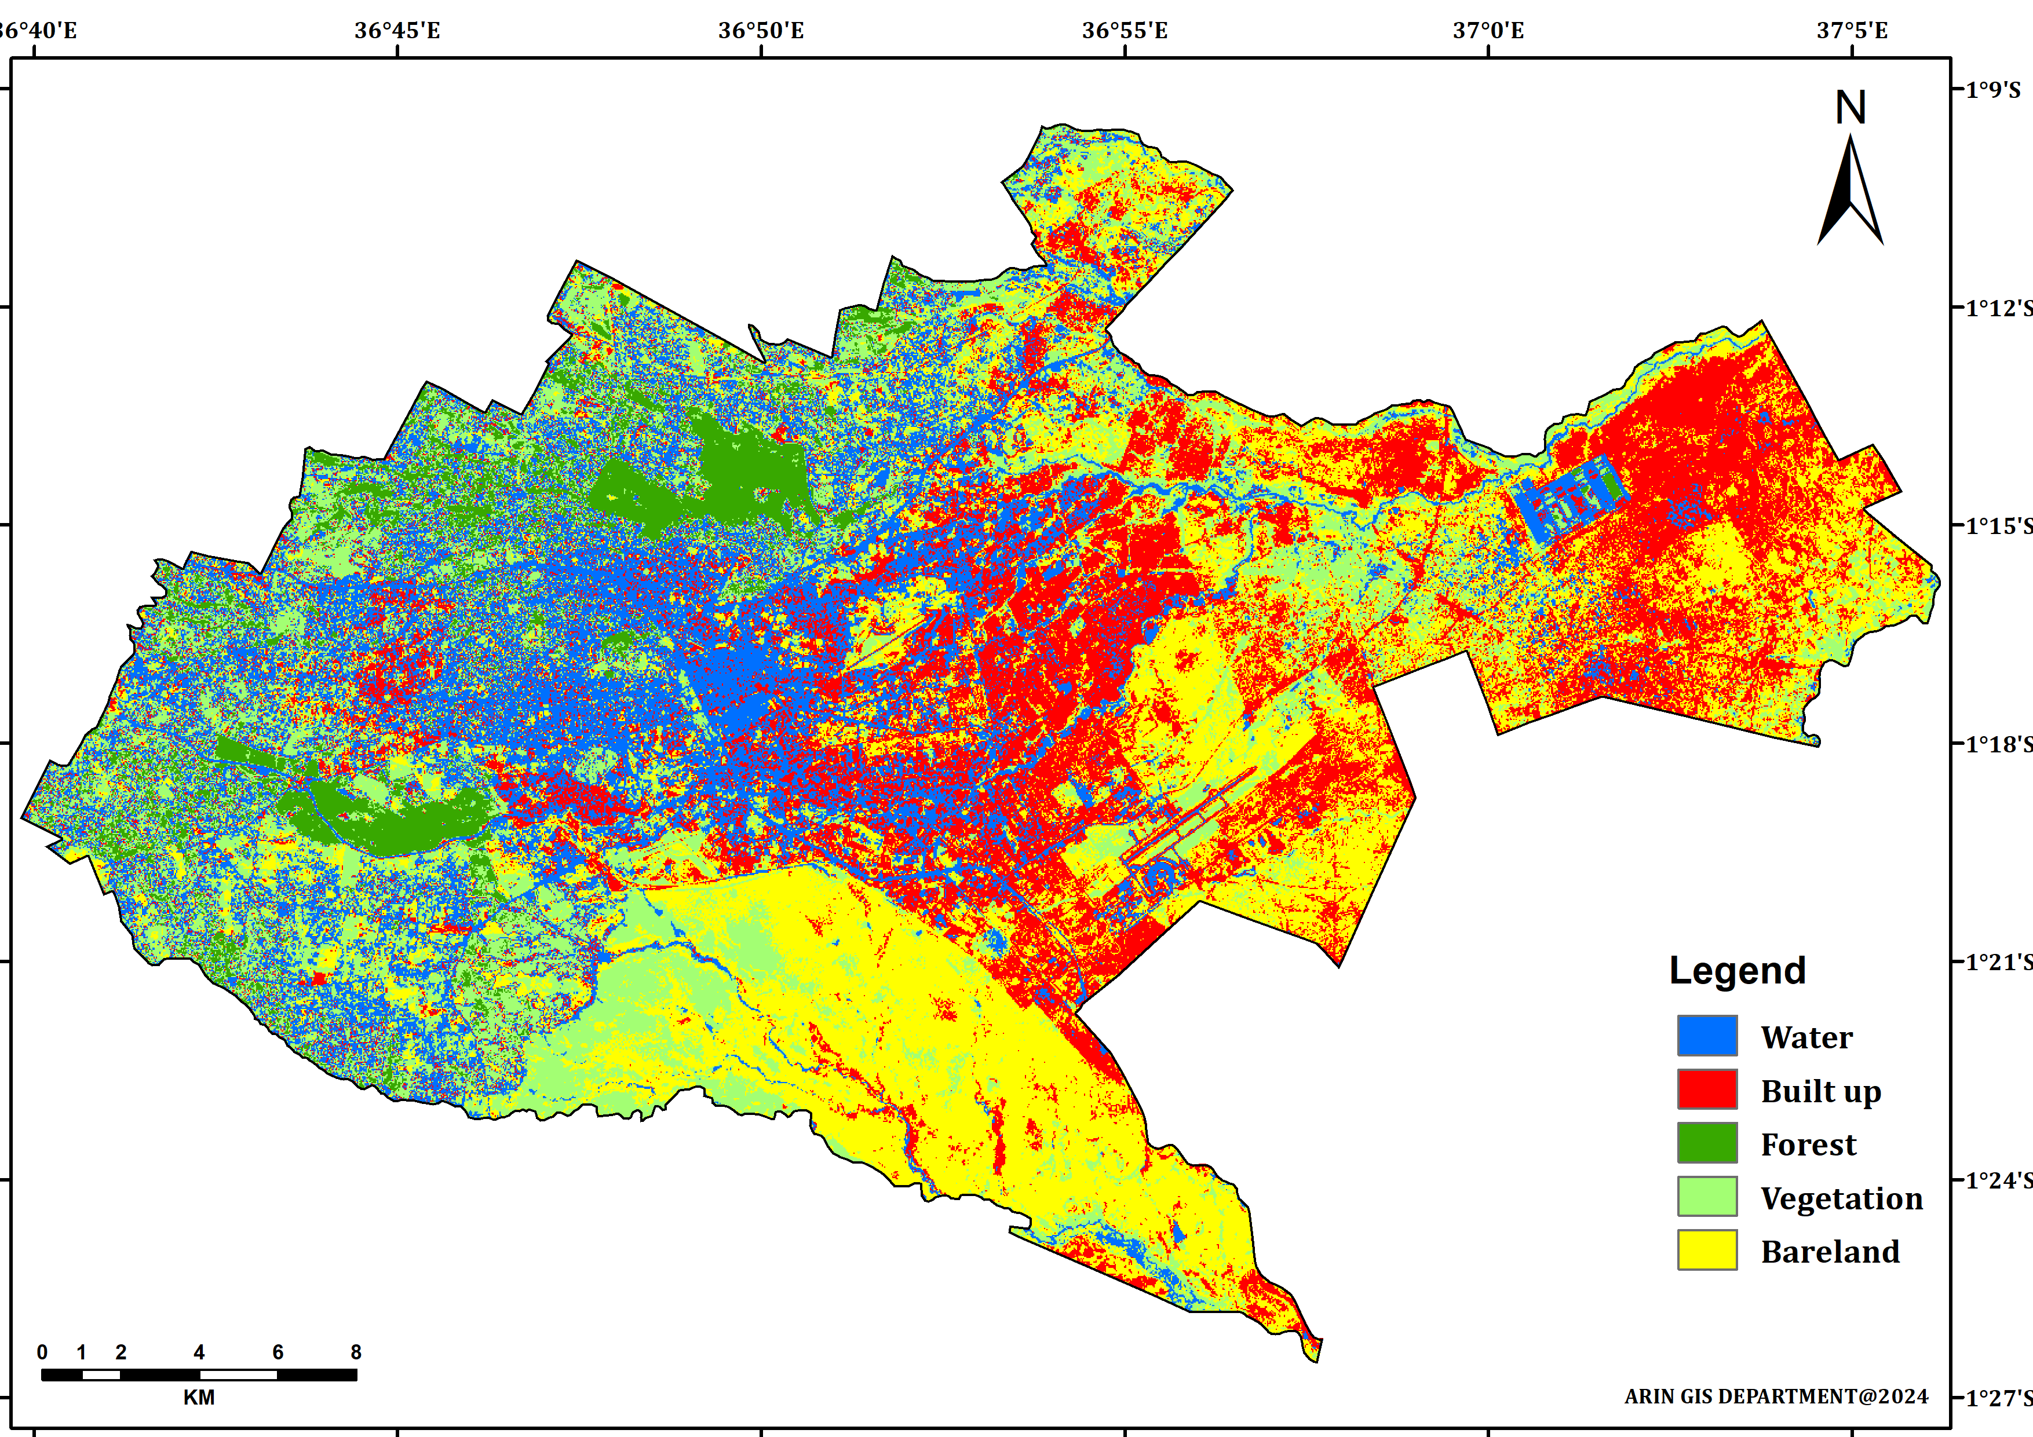

Fig 1: Land use land cover 2014

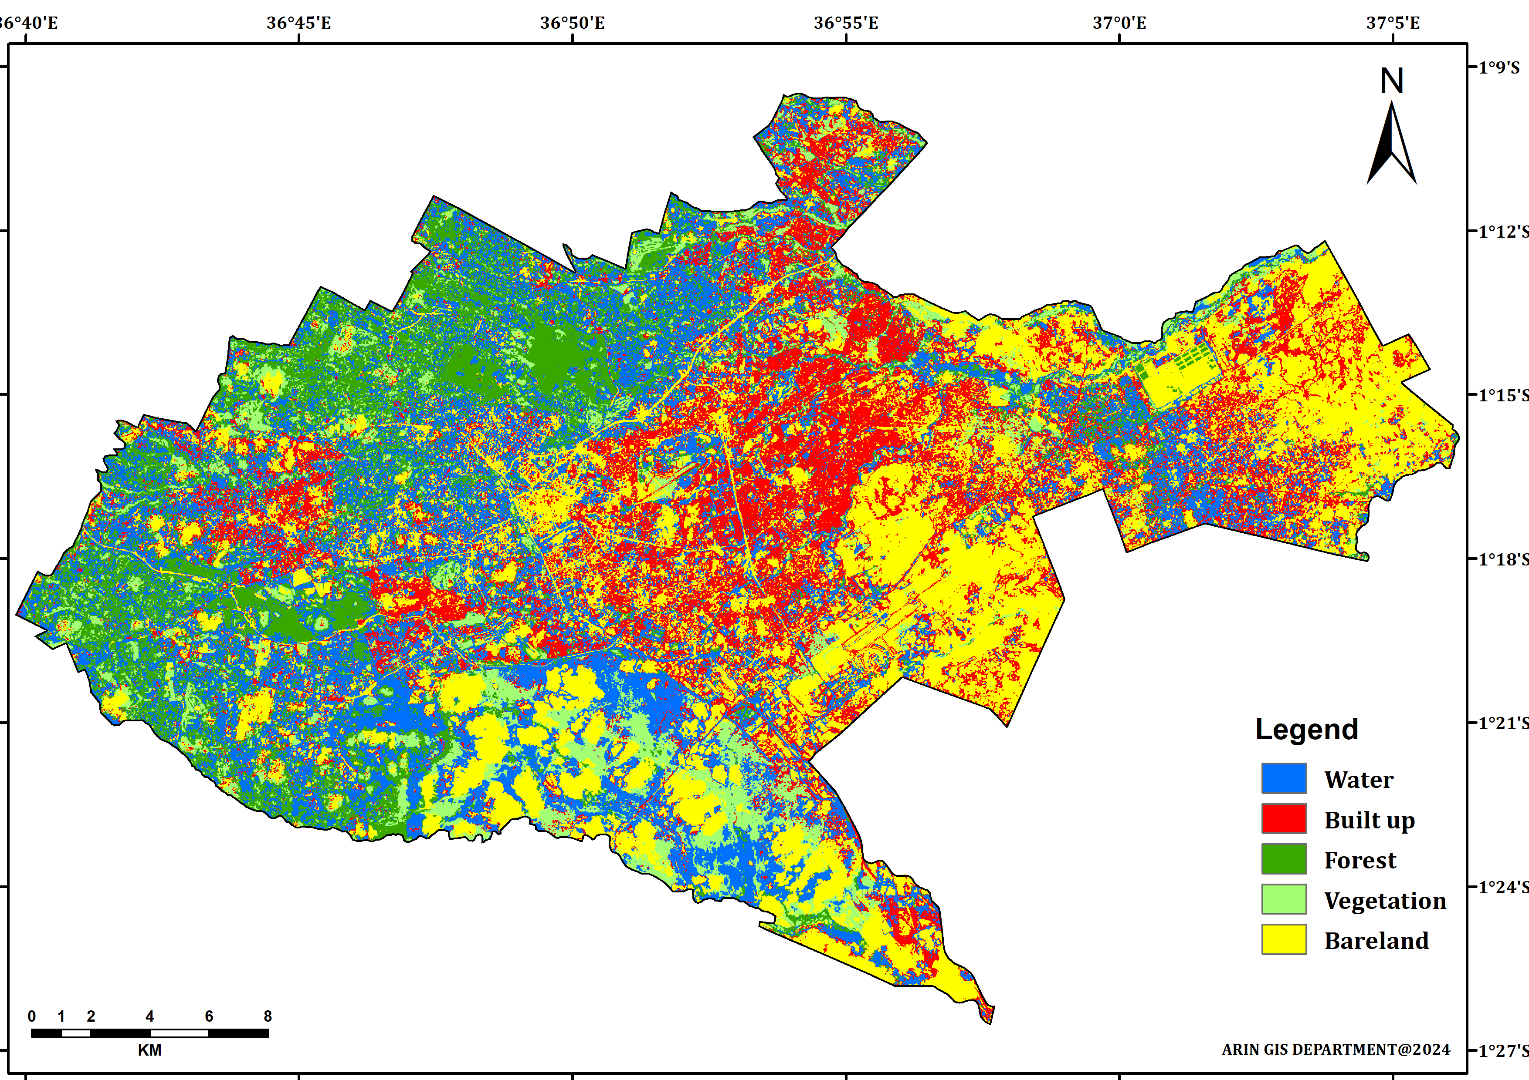

Fig 2: Land use land cover 2019

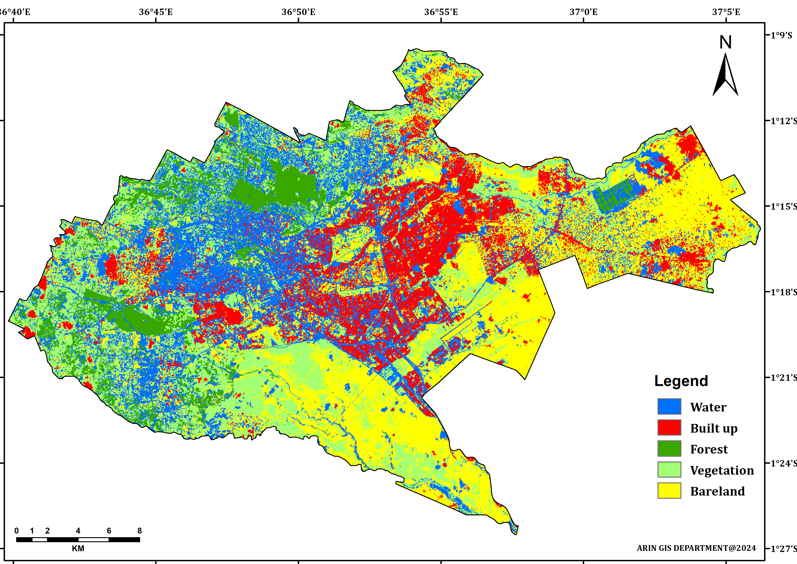

Fig 3: Land use land cover 2024